COMP6009 Assignment Part A

A Danger-Aware A* Agent for CoinTex

Colombo Group 08
Pavithra Solomons (24079123), Ravindu Chandrasekara (24100201), Rashmika Dilshan (20543909)

Contents

- Part 1: Understanding the greedy program
- Part 2: Our proposed algorithm
- Part 3: Performance comparison
- Part 4: Future work
- Conclusion
- Appendix A: Files and how to run them
- Appendix B: Results for every level
- References

All results in Part 3 come from 360 games played in the real CoinTex game on our laptops. 3 agents, 24 levels and 5 runs per level, saved by main_partA.py to partA_results.csv. We also wrote a small copy of the game rules without graphics, sim_partA.py. We only used it to tune our agent and to draw Figure 3.

Part 1: Understanding the greedy program

How main_work_greedy.py plays

The program is the CoinTex game with an agent added on top. When a level starts, screen_on_enter starts the monsters and fires moving and then starts a thread called CollectCoinThread. This thread is the agent. It moves the character by calling start_char_animation, the same method a mouse click uses.

Figure 1 shows the loop. The process begins with the agent sending the character to the starting point (0.1, 0.1); then identifying the location of the coins, monsters and fire. Coins that are within a range of 0.3 from monsters and fires are removed. Also, the Manhattan distance between all the pairs of points is calculated. findMinRoute creates the path to visit any unvisited nearest coin. The character then jumps to each coin on the route, one jumps every 0.4s, and the agent repeats the whole thing until no coins are left.

This is greedy best-first search. It always picks what looks closest and only looks at the distance still to go. And this can take you “straight to the (wrong) goal”. In CoinTex the nearest coin is often the wrong choice, because a monster or a fire is in the way.
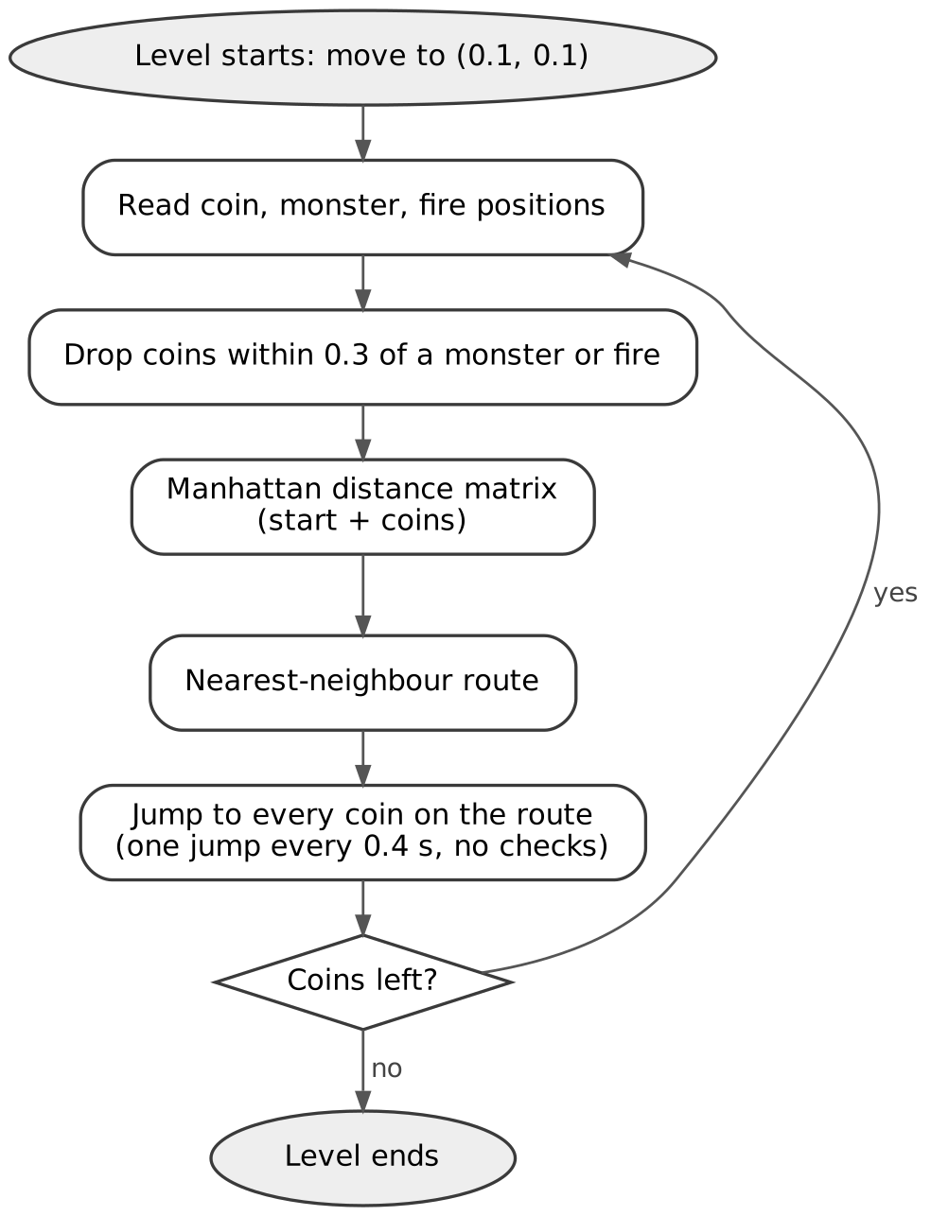
Figure 1: Original greedy agent flow

1.2 What goes wrong

We read the code and watched the agent play and found the problems in Table 1. G1 and G2 are the main reasons it dies on harder levels.

# | Problem | What happens in the game
G1 | Monsters and fires are only used to remove coins when planning | The jump from one coin to the next can go straight through a monster or a fire
G2 | The whole route is planned from one snapshot | The monsters keep moving while the agent works through the route, so the plan goes out of date
G3 | The start point is always (0.1, 0.1) | Every new plan is worked out from the corner, not from where the character really is
G4 | check_coin deletes items from the list it is looping over, and a bare except hides the errors | The wrong coins can be removed, and some coins near hazards are not removed at all
G5 | The thread does not stop when the character dies | On the next level two agents move the same character. The thread also crashes with a TypeError when the coins run out
G6 | time.perf_counter() is called but the result is never used | Nothing is timed or saved, so the agent’s performance cannot be measured
Table 1: Greedy program problems

1.3 Two things about the game that changed our thinking

Every jump takes 0.25s (char_anim_duration), however far it goes. So, the time to finish a level depends on how many jumps the agent makes, not how far it travels. The greedy agent tries hard to keep the distance short, but that saves no time in this game. The game also takes away one life point for every frame when the character touches a monster or fire, and the character dies after 20 to 35 frames. That is only about a third to half a second of contact. A quick brush past a hazard is fine, but staying near one is deadly. So, the agent needs to know when it will be near a hazard as well as where. From cointex.kv, the character and the monsters are 0.15 of the screen wide and a fire is 0.03. A monster hits when the two centres are within 0.075 of each other, and a fire hits (or a coin is collected) when they are within 0.05.

1.4 The task environment

Table 2 describes the task using PEAS. The game is fully observable, because the agent can read every position. It is not deterministic, because the monsters pick random targets. It is also dynamic, because the hazards keep moving while the agent thinks. The monsters are not trying to beat the agent; they just move at random.

PEAS | CoinTex
Performance measure | Collect every coin quickly without running out of life
Environment | One level. Coins in random places, monsters walking to random points, fires moving back and forth
Actuators | Jump to a point on the screen (start_char_animation), which takes 0.25 s
Sensors | The positions of the character, coins, monsters and fires
Table 2: CoinTex task environment (PEAS)

Part 2: Our proposed algorithm

2.1 Why we chose A*

We think collecting coins in CoinTex is really a path-finding problem with moving obstacles. A coin that is close but sits behind a monster is not a good target, because going for it can end the level. That is why the monster, and fire positions must be part of the decision, even though the goal is only to collect coins.

A* fixes the weakness of greedy search. It ranks each point by f(n) = g(n) + h(n), where g(n) is the real cost of the path so far and h(n) is a guess of the cost still to go. It always expands the point with the lowest f(n), and it stops when a goal is taken off the fringe (Hart et al., 1968; Russell & Norvig, 2021). A* identifies the cheapest path, if there are no overestimates from the guess. We put danger into g, so the cheapest path is the one that best balances distance and risk.

Search problem setup:
- State space: Cells of a 40 × 40 grid over the screen.
- Successor function: Player icon moves to any of the 8 neighbouring cells. A move costs its length × (1 + 8 × danger).
- Start state: The cell the character is in now.
- Goal test: The cell has a coin in it.

Four questions can be asked about any search. Our answers are in Table 3.

Question | Our answer
Space | 1,600 grid cells, 8 moves from each
Objective | The cheapest path to any coin, where cost is distance weighted by danger
Guidance | h(n) = straight-line distance to the nearest coin
Budget | One decision per 0.25s jump. A decision took 6.7ms on average on our laptop
Table 3: Search space, objective, guidance and budget

Our heuristics come from a relaxed problem. In a hazardless scenario cheapest path to a coin is always a straight line. The actual path may be equally costly or costlier, but the guess never overestimates. Every move as a bare minimum costs its own length, which in turn creates consistency as our A* stores the already visited closed set of cells.

2.2 Flow of the algorithm

Figure 2 shows one decision. Every 0.25s agent repetition occurs till all the coins are captured or the character dies.
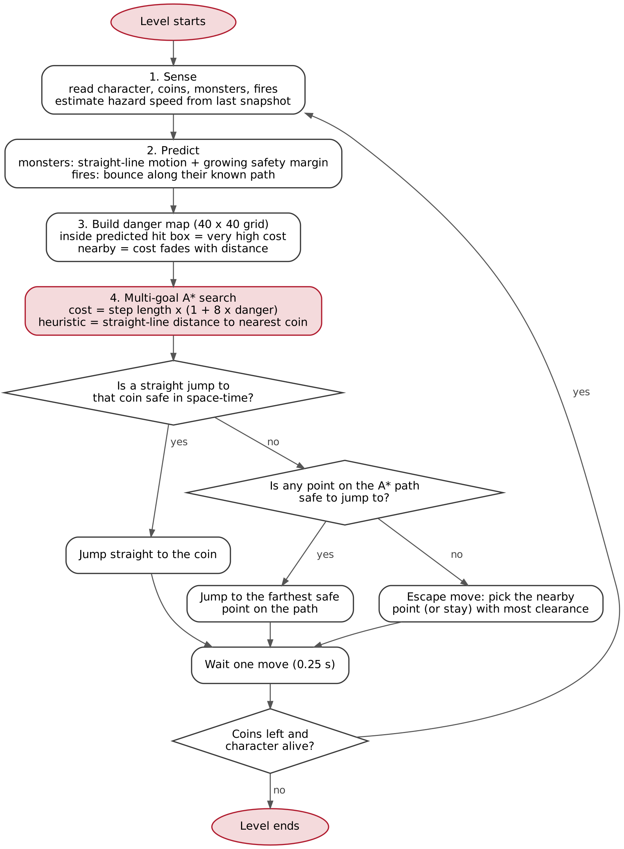
Figure 2: Danger-aware A* agent flow
The same loop as pseudo-code:
every 0.25 s, until no coins are left or the character is dead:
world = snapshot() # character, coins, monsters, fires
speeds = change in each hazard position since last snapshot
danger = 40 x 40 grid of zeros
for t in (0, 0.15, 0.30, 0.45, 0.60) seconds ahead:
predict every monster and fire at time t
cell inside hit box + margin(t) -> danger = 40 x weight(t)
any other cell -> danger = exp(-clearance/sigma) x weight(t)
path, coin = A*(start = character's cell,
goals = every coin's cell,
step cost = length x (1 + 8 x danger),
guess = straight-line distance to nearest coin)
if the straight jump to that coin is safe in space-time:
target = coin
elif some point on the path is safe to jump to:
target = farthest safe point on the path
else:
target = nearby point (or stay) with the most clearance
move(target)

2.3 How monsters and fires are included

Before planning happens, agent hazard prediction occurs in the next 0.6s. For a monster it assumes the monster keeps its current speed and direction and adds a safety margin that grows further ahead it looks, because monsters can turn at any time. Fires are easier, because each fire moves back and forth between two fixed points given in cointex.kv. The agent works out where the fire is on that line and which way it is going.

These predictions become a danger map. A cell inside a predicted hit box gets a very high danger value, and the cells around it get a value that fades with distance. Predictions further ahead count a bit less, because they are less certain. In Figure 3 the dark red cells are where a monster or fire is expected at some point in the next 0.6 s. The blue line is the A* path to the cheapest coin, and the black arrow is the jump the agent chose.

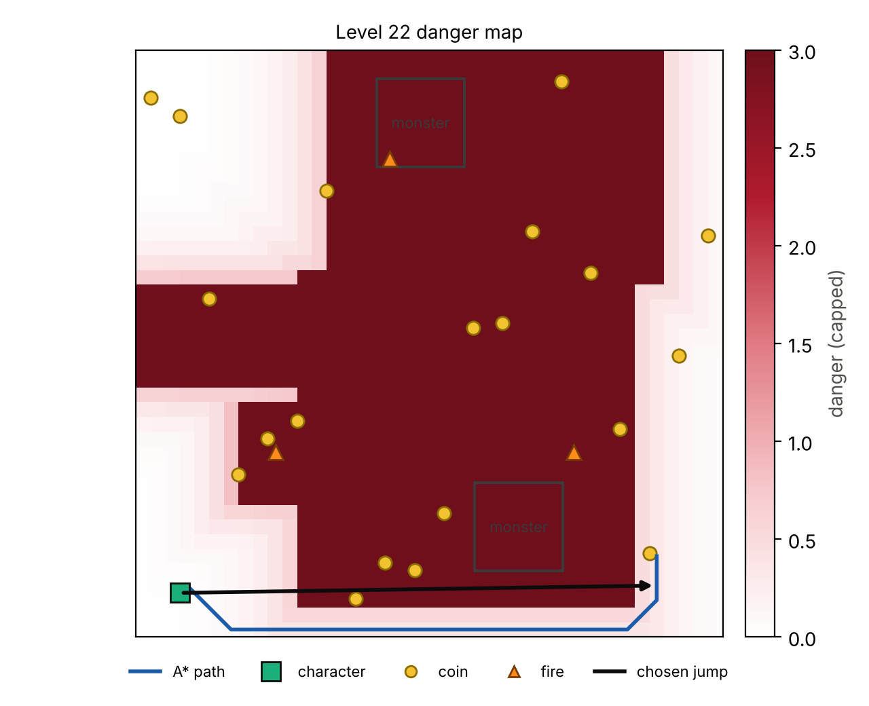
Figure 3: Level 22 danger map and chosen jump

2.4 Choosing the jump

Moving one cell at a time along the A* path would be very slow, since every jump takes 0.25 s. So, the agent looks for the longest straight jump it can make. First, it checks whether it can jump straight to the coin. If not, it checks the points on the path from the far end back and takes the first one that is safe.

A jump lasts 0.25s and is considered safe if all the points in the path are clear by the time the character is present. Agent figures out the timings of the character passing the points and the locations of the hazards at those moments. In this way a jump can cross even the dangerous cells as shown in Figure 3. In a hazardous situation, when a monster gets close, no points in the path are safe. Agent stays still and tries 64 points around and picks the furthest point from danger.

2.5 What is new compared with the greedy agent

Table 4 sums up the differences.

 | Original greedy agent | Our A* agent
Choosing a coin | Nearest by Manhattan distance; the whole route is fixed at the start | Cheapest path once danger is counted; chosen again before every jump
Monsters and fires | Only used to remove coins within 0.3 when planning | Predicted 0.6 s ahead and added to the cost of every cell
Moving | Straight jumps to each coin with no checks | Only jumps that are clear when the character passes
Replanning | After the whole route | Every 0.25 s
Planning starts from | Always (0.1, 0.1) | Where the character really is
In danger | Does nothing | Moves to the nearby point with the most room
Search | Nearest neighbour route | A* with a guess that never overestimates
Table 4: Greedy agent vs A* agent

2.6 Keeping the test fair

All three agents play the same game. We copied the game code from main_work_greedy.py into main_partA.py and only added a few lines that log when a level starts and how it ends. Each agent is in its own file, reads the same positions and moves through the game’s own start_char_animation. The greedy logic is copied into agent_greedy.py without changes, except that it now stops cleanly at the end of a level instead of crashing.

We chose the A* settings (the danger weight of 8, the safety margins and how far ahead to look) by testing in sim_partA.py, a small copy of the game rules without graphics that can play hundreds of levels in a few minutes. None of the results in Part 3 come from this simulator.

Part 3: Performance comparison

3.1 How we tested

We compared three agents:
- Greedy: the original logic from main_work_greedy.py, unchanged.
- Genetic algorithm (GA): the GA agent that comes with CoinTex in PlayerGA/TutorialProject/main.py (Gad, 2026). It uses PyGAD (Gad, 2021) with 1000 candidate target points. Each point is scored by how close it is to the first coin in the list, with a penalty for being within 0.3 of a monster or fire, and the character moves whenever the best score changes.
- A*: Our agent from Part 2.

The tutorial GA does not run on PyGAD 3.9.2. Therefore, changes were made only to what was needed. Fitness function now takes three arguments, on_generation replaces callback_generation, a short sleep replaces delay_after_gen, and we set keep_elitism=0 and keep_parents=0. The last change matters. PyGAD 3 reuses old fitness scores for the best solutions, and in a moving game those scores go out of date, the best score stops changing and the character freezes.

Each agent played every level 5 times, so 120 games per agent. Every run is different as the coins are randomly placed. The game ends either when all coins are collected, or if the character dies, or after 60s. We measured:
- Success rate: the percentage of games where every coin was collected. We also count a level as completed if the agent won at least 3 of its 5 runs, which is how we read “percentage of levels completed” in the brief.
- Time to collect all coins: from the start of the level to the last coin, for successful games only.
- Life left: how much of life bar was left at the end.
- RACR: a new measure we propose in section 3.4.

In our first batch two game windows were open by mistake for greedy levels 1 to 3, and the batch then stopped after level 15. We removed those rows (the original file is kept as partA_results_raw_run1.csv), reran the missing greedy games on their own, and changed the program so a second window cannot write to the same file.

3.2 Overall results

Table 5 and Figure 4 show the overall results.

Measure | Greedy | GA | A* (ours)
Games won | 96 / 120 | 99 / 120 | 120 / 120
Success rate (95% range) | 80.0% (72 to 86) | 82.5% (75 to 88) | 100.0% (97 to 100)
Levels completed (3+ wins of 5) | 21 / 24 | 21 / 24 | 24 / 24
Levels won in all 5 runs | 12 / 24 | 12 / 24 | 24 / 24
Mean time to collect all coins (s) | 5.67 | 12.25 | 4.60
Jumps per successful game | 13.9 | 32.6 | 16.9
Life left (%) | 59.3 | 57.2 | 99.7
Deaths / timeouts | 24 / 0 | 21 / 0 | 0 / 0
Hit frames per game | 11.7 | 12.3 | 0.1
RACR (coins per second × life left) | 1.48 | 0.81 | 3.10
Planning time per decision (ms) | - | - | 6.7 (max 20.2)
Table 5: Overall results

All three agents won every level at least once, so the mean time is over all 24 levels, using each level’s average for the games that were won. That way no agent looks faster just because it only wins the easy levels.
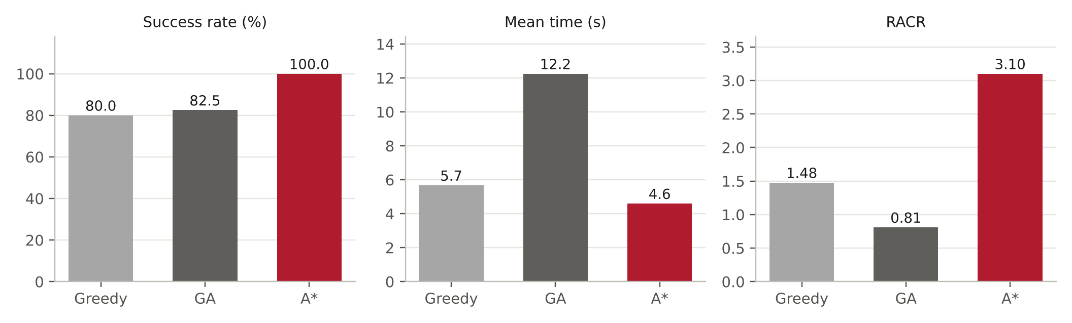
Figure 4: Overall results

Our A* agent won all 120 of its games and completed all 24 levels. The GA won 99 (82.5%) and the greedy agent won 96 (80.0%). Both completed 21 of the 24 levels. The 95% ranges in the table show how much each rate could change with more runs. The A* range does not overlap with the other two, so the difference is bigger than luck. The greedy and GA ranges do overlap, so we cannot say one of them wins more often than the other.

A* was also much safer. It ended with 99.7% of its life on average and touched a hazard for only 0.1 frames per game, compared with 11.7 frames for greedy and 12.3 for the GA.
It was also the fastest. Across all 24 levels, A* took 4.60s on average, against 5.67 s for greedy and 12.25s for GA. Level by level, A* was faster than greedy on 22 of the 24 levels and faster than the GA on all of them.

3.3 Results level by level
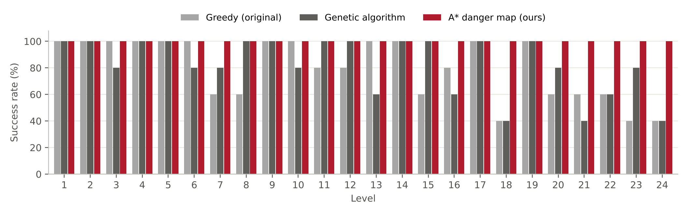
Figure 5: Success rate by level
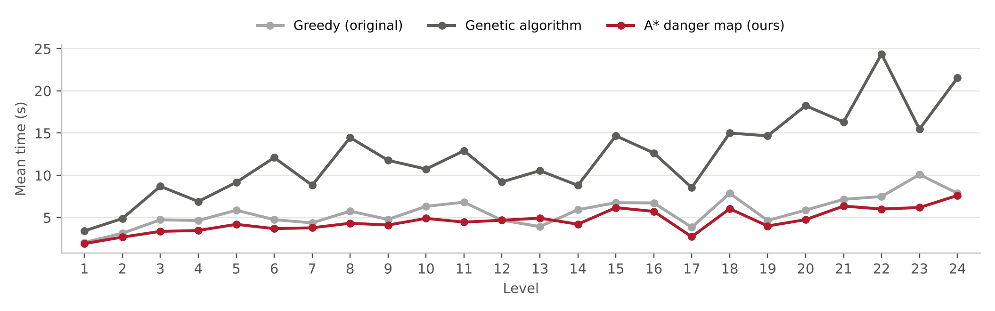
Figure 6: Mean completion time by level

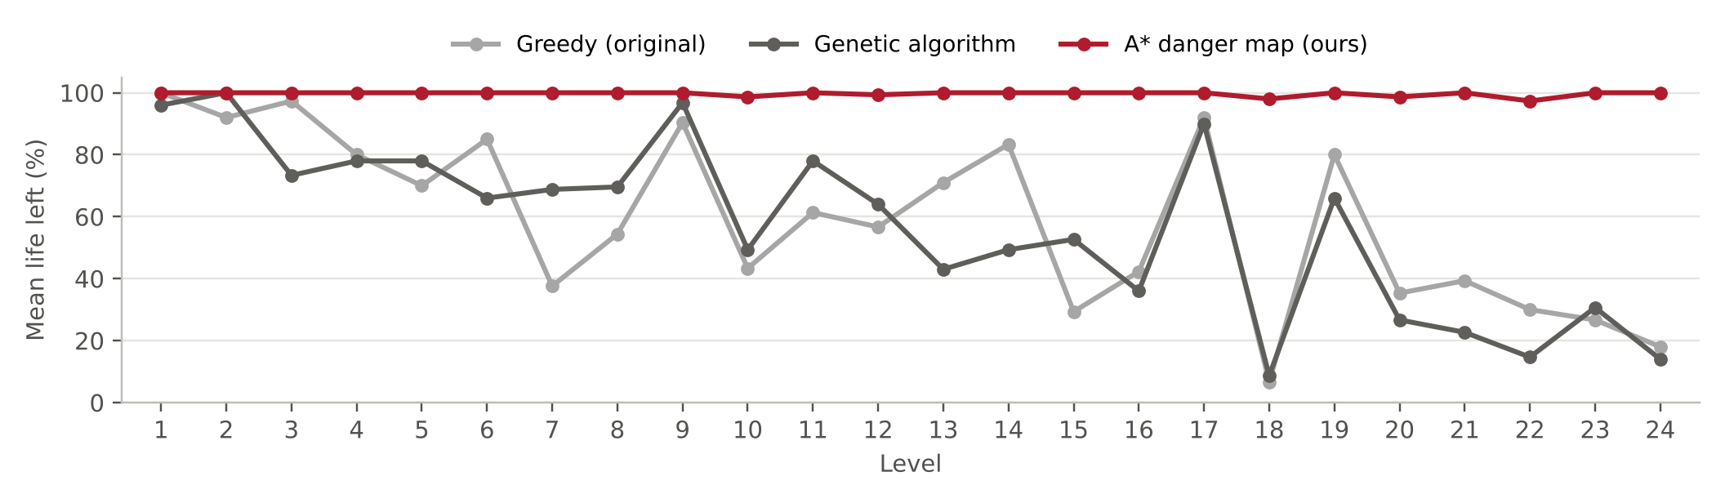
Figure 7: Life left by level

Figure 5 shows where the other two agents lose. Greedy lost 24 games on 12 levels, with the worst levels been 18, 23 and 24 (2 wins out of 5; level 18 has 3 monsters and 4 fires; level 23 has 2 monsters and 2 fires; level 24 has 3 monsters and 2 fires), followed by 6 levels with 3 wins out of 5. Every greedy loss was a death, not a timeout, which fits problem G1, and the straight jumps between coins are never checked. The GA lost 21 games on 12 levels, worst levels been 18, 21 and 24 (2 wins out of 5; level 18 has 3 monsters and 4 fires; level 21 has 2 monsters and 4 fires; level 24 has 3 monsters and 2 fires), followed by 3 levels with 3 wins out of 5. It aims at the first coin in the list and only scores the point where it lands, so the path to that point can go right through a hazard. Both agents struggled on levels 18 and 24. A* won every game at every level.
In Figure 6 the GA’s time goes up with the number of coins on a level. It needed 32.6 jumps per win, about twice as many as A* (16.9), because it always heads for the first coin in the list even when others are closer. Figure 7 shows the life left. Greedy and the GA lose more life on the later levels (greedy drops from 72% on levels 1 to 12 to 46% on levels 13 to 24, and the GA from 76% to 38%), while A* never drops below 97% on any level.

3.4 Our extra measure: risk adjusted collection rate

Success rate and time each show only part of the picture. A win with 5% life left counts the same as a win without a scratch, and the time measure ignores the games that were lost. So, we propose one number that combines speed and safety:
RACR = (coins collected ÷ time in seconds) × fraction of life left

A fast game with no damage scores high. A fast but careless game scores lower because its life is low, and a game that ends in death scores zero, even if many coins were collected first. A* scored 3.10, which is about twice the greedy agent (1.48) and nearly 4 times the GA (0.81). RACR also puts greedy ahead of the GA, even though the GA won slightly more games. The GA is much slower and takes more damage on the way, so RACR scores it lower. It’s fair to assume that an agent that scrapes through slowly with little life left is not really playing better.

3.5 Why the A* agent does better

The safety comes from checking every jump against where the hazards will be, and from planning again every 0.25 s from where the character really is. That is why A* touched a hazard for only 0.1 frames per game. The greedy agent plans once per route and then jumps without looking, and the GA only checks the point it lands on, so both walk into monsters and fires.

The speed comes from two things. First, A* moves more often. The original greedy code waits 0.4 s after every jump, while A* moves again as soon as the 0.25 s animation ends. In winning games greedy spent 0.38 s per jump and A* spent 0.27 s. We kept the greedy timing exactly as it was given, because the brief asks us to compare with the original program, but this means part of the time saved comes from the faster rhythm and not from the search itself. Second, A* rarely wastes jumps. It made 16.9 jumps per win, a few more than greedy (13.9) because it sometimes steps around a hazard, but about half as many as the GA (32.6). The method is also cheap to run. One decision took 6.7 ms on average and 20.2 ms at most, which is far less than the 250 ms each jump takes.

3.6 Limitations

In one instance games ran on one laptop, so the times would be a bit different on another computer, especially for the GA, which scores 1000 points in Python before every move. Five runs per level is enough to see the overall pattern, but one level’s success rate moves in steps of 20%, so small differences between single levels should not be over read. We tuned the A* settings in our simulator, which copies the game rules but not every detail of Kivy. The GA we compared is the tutorial GA with only the changes listed above, not a GA properly tuned for this game.

Part 4: Future work

4.1 A hybrid of the genetic algorithm and A*

Our agent always goes for the coin with the cheapest safe path from where it is now. That is still a short sighted choice about the order of the coins. The character can take a nearby coin, but may ignore coins isolated in far corners, which at the end will cost extra jumps. A GA is useful at searching over orders, and A* is helpful in finding safe paths. Therefore, a hybrid approach could use both:
- Each GA solution is an order of the remaining coins (a permutation). It would use order-based crossover and swap mutation, so every child is still a valid order.
- The fitness of an order is the total A* path cost from coin to coin on the current danger map. An order that leaves a coin stranded gets a high cost.
- The best order changes slowly, so the GA could run in the background and update the order every second or so, while A* keeps planning the next safe jump every 0.25 s.

This should help most on levels 21 to 24, which have 18 to 25 coins. The risk is speed. One decision from our agent takes about 7 ms, so scoring a whole population of orders would need cheaper path estimates. A simpler hybrid would use GA to tune our A* settings. We picked the danger weight, the margins and the look ahead time by hand. A GA could search for better values in the simulator, using success rate and time as the fitness.

4.2 Other ideas

Markov model of the monsters in the game: We assume a monster keeps its current speed and direction, which is a simple form of the Markov assumption. And other questions we had are, where is the monster, and where might it move? A proper model, updated every frame like HMM filtering, would give the chance of a monster being in each cell. The danger map could then use real probabilities instead of fixed margins.

Expectimax: The monsters move at random and are not trying to catch the agent. In this case the agent should plan for the average outcome (expectimax), not the worst case (minimax). Looking at two or three jumps ahead this way would let the agent take a small risk when it saves a lot of time.

Time in the search: Our A* treats the danger map as fixed and only checks timing when it picks a jump. Adding time as a third dimension of the grid (Silver, 2005) would let the agent plan to wait for a monster to pass and then go.

Conclusion

The greedy agent in main_work_greedy.py picks coins by distance and stops looking at the monsters and fires once it starts moving, which is why it dies on the harder levels. We replaced it with an A* agent that predicts where the hazards will be, finds the cheapest safe path to a coin and only makes jumps that are clear when the character passes. In 120 games it won 120, compared with 96 for the greedy agent and 99 for the tutorial GA. It was also the fastest of the three, finished with 99.7% of its life on average, and needed only about 7 ms to plan each move.

Appendix A: Files and how to run them

All files are in CoinTex/PlayerGA/TutorialProject.

File | Purpose
main_work_greedy.py | Original greedy program from Blackboard (unchanged)
agent_greedy.py | The same greedy logic, run through our test program
agent_ga.py | Tutorial GA from main.py, updated for PyGAD 3.9.2
agent_astar.py | Our danger-aware A* agent
partA_common.py | Shared code. The position snapshot and the read / move / wait calls
main_partA.py | The game plus our test program plays levels by itself, times them and saves results
sim_partA.py | Copy of the game rules without graphics, used for tuning only
analyse_partA.py | Summary tables and charts from the results file
run_partA_experiments.bat | Runs all three agents on all levels, then the analysis
partA_results.csv | One row per game (the data behind Part 3)
partA_results_raw_run1.csv | First batch, before the duplicated greedy rows were removed
Table 6: Project files

Software: Windows, Python 3.12.10, Kivy 2.3.1, PyGAD 3.9.2, NumPy 2.5.4.

To run everything, double click run_partA_experiments.bat. To run one agent from a Command Prompt in TutorialProject:
..\venv\Scripts\activate
set AGENT=astar
set LEVELS=1-24
set RUNS=5
python main_partA.py
python analyse_partA.py partA_results.csv

AGENT can be greedy, ga or astar. Games already in the results file are skipped, so a stopped batch can be started again.

Appendix B: Results for every level

Table 7 shows the wins out of 5 runs and the mean time in seconds for the games that were won.

Level | Coins | Monsters | Fires | Greedy wins | Greedy time (s) | GA wins | GA time (s) | A* wins | A* time (s)
1 | 5 | 1 | 0 | 5/5 | 2.05 | 5/5 | 3.42 | 5/5 | 1.92
2 | 8 | 1 | 0 | 5/5 | 3.14 | 5/5 | 4.89 | 5/5 | 2.69
3 | 12 | 1 | 0 | 5/5 | 4.74 | 4/5 | 8.70 | 5/5 | 3.36
4 | 10 | 1 | 1 | 5/5 | 4.65 | 5/5 | 6.90 | 5/5 | 3.47
5 | 15 | 1 | 2 | 5/5 | 5.87 | 5/5 | 9.17 | 5/5 | 4.20
6 | 12 | 1 | 3 | 5/5 | 4.75 | 4/5 | 12.10 | 5/5 | 3.69
7 | 10 | 3 | 0 | 3/5 | 4.37 | 4/5 | 8.82 | 5/5 | 3.79
8 | 15 | 2 | 0 | 3/5 | 5.76 | 5/5 | 14.47 | 5/5 | 4.33
9 | 12 | 2 | 0 | 5/5 | 4.78 | 5/5 | 11.78 | 5/5 | 4.12
10 | 14 | 3 | 0 | 5/5 | 6.33 | 4/5 | 10.74 | 5/5 | 4.90
11 | 15 | 2 | 1 | 4/5 | 6.82 | 5/5 | 12.91 | 5/5 | 4.46
12 | 12 | 2 | 1 | 4/5 | 4.68 | 5/5 | 9.23 | 5/5 | 4.68
13 | 10 | 2 | 2 | 5/5 | 3.93 | 3/5 | 10.55 | 5/5 | 4.93
14 | 15 | 0 | 6 | 5/5 | 5.93 | 5/5 | 8.81 | 5/5 | 4.21
15 | 16 | 2 | 3 | 3/5 | 6.76 | 5/5 | 14.68 | 5/5 | 6.18
16 | 15 | 3 | 2 | 4/5 | 6.73 | 3/5 | 12.65 | 5/5 | 5.73
17 | 10 | 0 | 4 | 5/5 | 3.85 | 5/5 | 8.55 | 5/5 | 2.73
18 | 15 | 3 | 4 | 2/5 | 7.88 | 2/5 | 15.01 | 5/5 | 6.05
19 | 12 | 0 | 6 | 5/5 | 4.65 | 5/5 | 14.67 | 5/5 | 4.00
20 | 15 | 0 | 8 | 3/5 | 5.88 | 4/5 | 18.25 | 5/5 | 4.75
21 | 18 | 2 | 4 | 3/5 | 7.16 | 2/5 | 16.32 | 5/5 | 6.36
22 | 20 | 2 | 4 | 3/5 | 7.49 | 3/5 | 24.36 | 5/5 | 6.01
23 | 25 | 2 | 2 | 2/5 | 10.09 | 4/5 | 15.47 | 5/5 | 6.19
24 | 20 | 3 | 2 | 2/5 | 7.88 | 2/5 | 21.54 | 5/5 | 7.61

Table 7: Results by level

References

Curtin University. COMP6009 Study Material. Blackboard. https://lms.curtin.edu.au/
Gad, A. F. (2021). PyGAD: An intuitive genetic algorithm Python library [Preprint]. arXiv. https://doi.org/10.48550/arXiv.2106.06158
Gad, A. F. (2026). CoinTex [Computer software]. GitHub. https://github.com/ahmedfgad/CoinTex
Hart, P. E., Nilsson, N. J., & Raphael, B. (1968). A formal basis for the heuristic determination of minimum cost paths. IEEE Transactions on Systems Science and Cybernetics, 4(2), 100–107. https://doi.org/10.1109/TSSC.1968.300136
Russell, S., & Norvig, P. (2021). Artificial intelligence: A modern approach (4th ed.). Pearson.
Silver, D. (2005). Cooperative pathfinding. In Proceedings of the First Artificial Intelligence and Interactive Digital Entertainment Conference (pp. 117–122). AAAI Press.

